# YouTube

## Definition

**# Source**: **Chatgpt (GPT-5-Standard) at [8/27/2025]**

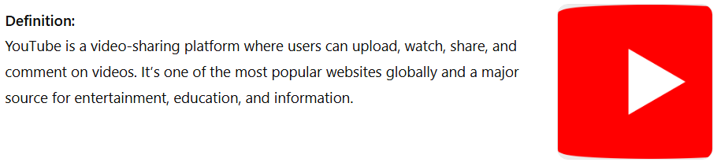

YouTube is a video-sharing platform where users can upload, watch, share, and comment on videos. It’s one of the most popular websites globally and a major source for entertainment, education, and information.

## Key Features

* **# Source**: **Chatgpt (GPT-5-Standard) at [8/27/2025]**
* **Video Hosting & Streaming** – Users can upload videos in various formats.
* **Free Access** – Watching videos is free; optional paid plans exist (YouTube Premium).
* **Channels & Subscriptions** – Creators have channels; viewers can subscribe.
* **Live Streaming** – Real-time broadcasts.
* **Community Interaction** – Likes, comments, playlists, and community posts.

## Ownership

**# Source**: **Chatgpt (GPT-5-Standard) at [8/27/2025]**

* Owned by **Google** (acquired in 2006).

## Uses

**# Source**: **Chatgpt (GPT-5-Standard) at [8/27/2025]**

* Entertainment (music videos, vlogs, gaming)
* Education (tutorials, courses)
* Reviews & Analysis (tech, movies, products)
* Marketing & Advertising

## Website

**# Source**: **Chatgpt (GPT-5-Standard) at [8/27/2025]**

[https://www.youtube.com](https://www.youtube.com/)